

**Industrial Internship Report on**

**” Console-based expense tracker application ”**

**Prepared by**

**[Sahil Ahmad**

**Himanshu**

**Dushyant]**

|  |
| --- |
| *Executive Summary* |
| This report provides details of the Industrial Internship provided by upskill Campus and The IoT Academy in collaboration with Industrial Partner UniConverge Technologies Pvt Ltd (UCT).  This internship was focused on a project/problem statement provided by UCT. We had to finish the project including the report in 6 weeks’ time.  My project was Console-based expense tracker application. It is an expense tracker application on which user can add their expenses and salary and keep the track of its expenses. This internship gave me a very good opportunity to get exposure to Industrial problems and design/implement solution for that. It was an overall great experience to have this internship. |

**TABLE OF CONTENTS**

1 Preface 3

2 Introduction 4

2.1 About UniConverge Technologies Pvt Ltd 4

2.2 About upskill Campus 8

2.3 Objective 9

2.4 Reference 9

2.5 Glossary 10

3 Problem Statement 11

4 Existing and Proposed solution 12

5 Proposed Design/ Model 13

5.1 High Level Diagram (if applicable) 13

5.2 Low Level Diagram (if applicable) 13

5.3 Interfaces (if applicable) 13

6 Performance Test 14

6.1 Test Plan/ Test Cases 14

6.2 Test Procedure 14

6.3 Performance Outcome 14

7 My learnings 15

1. Future work scope 16

**Preface**

Summary of the whole 6 weeks’ work.

About need of relevant Internship in career development.

Brief about Your project/problem statement.

Opportunity given by USC/UCT.

How Program was planned

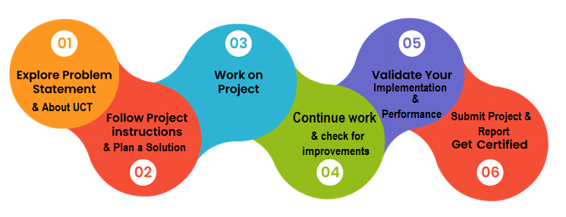

Your Learnings and overall experience.

Thank to all, who have helped you directly or indirectly.

* **Introduction**
* **About UniConverge Technologies Pvt Ltd**

A company established in 2013 and working in Digital Transformation domain and providing Industrial solutions with prime focus on sustainability and RoI.

For developing its products and solutions it is leveraging various**Cutting Edge Technologies e.g. Internet of Things (IoT), Cyber Security, Cloud computing (AWS, Azure), Machine Learning, Communication Technologies (4G/5G/LoRaWAN), Java Full Stack, Python, Front end**etc.

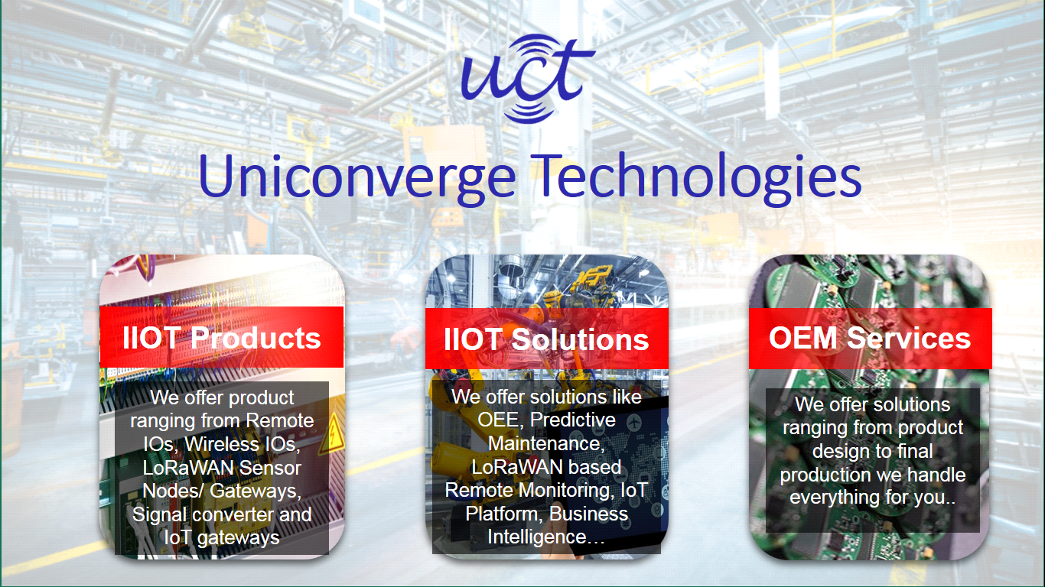

* **UCT IoT Platform (****)**

**UCT Insight** is an IOT platform designed for quick deployment of IOT applications on the same time providing valuable “insight” for your process/business. It has been built in Java for backend and ReactJS for Front end. It has support for MySQL and various NoSql Databases.

* It enables device connectivity via industry standard IoT protocols - MQTT, CoAP, HTTP, Modbus TCP, OPC UA
* It supports both cloud and on-premises deployments.

It has features to  
• Build Your own dashboard  
• Analytics and Reporting  
• Alert and Notification  
• Integration with third party application(Power BI, SAP, ERP)  
• Rule Engine

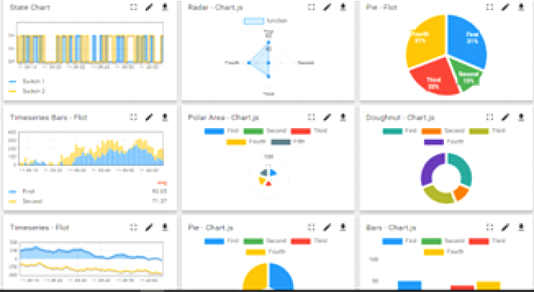 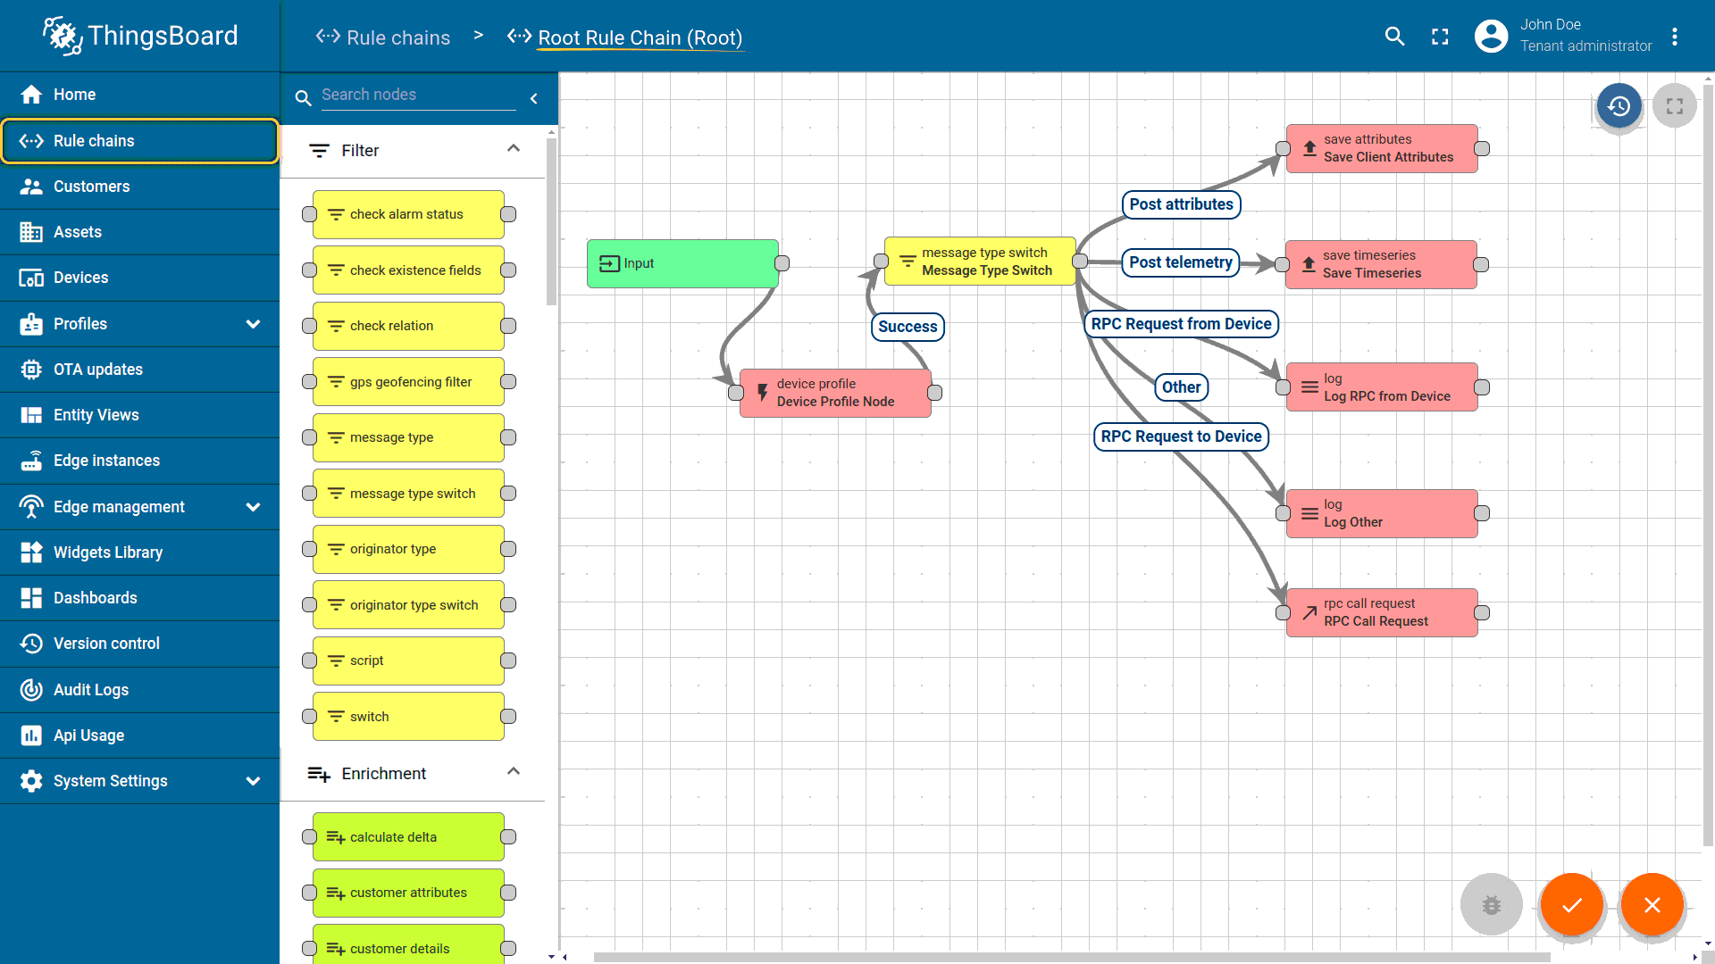

* **Smart Factory Platform (****)**

Factory watch is a platform for smart factory needs.

It provides Users/ Factory

* with a scalable solution for their Production and asset monitoring
* OEE and predictive maintenance solution scaling up to digital twin for your assets.
* to unleased the true potential of the data that their machines are generating and helps to identify the KPIs and also improve them.
* A modular architecture that allows users to choose the service that they what to start and then can scale to more complex solutions as per their demands.

Its unique SaaS model helps users to save time, cost and money.

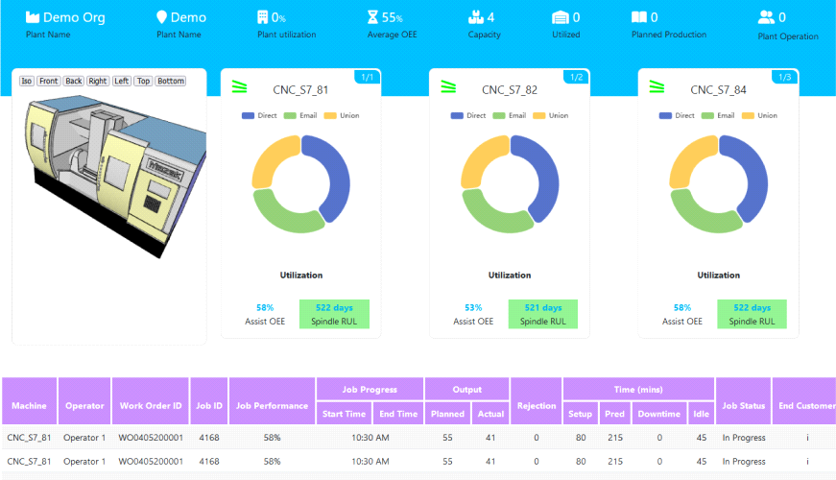 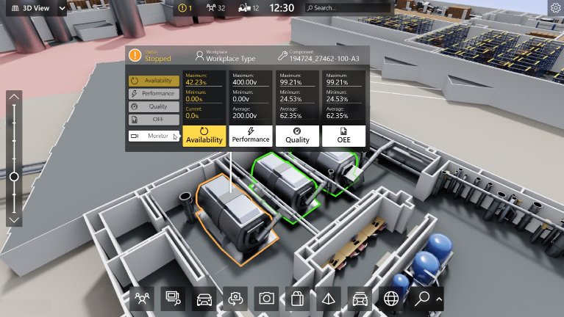

* 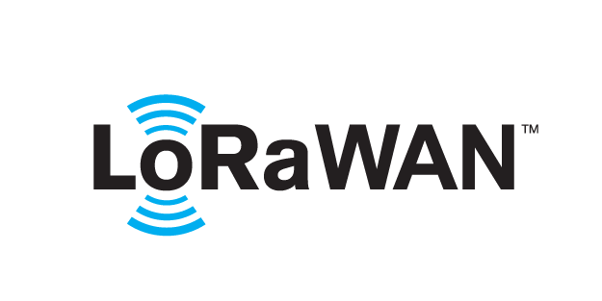 based Solution

UCT is one of the early adopters of LoRAWAN teschnology and providing solution in Agritech, Smart cities, Industrial Monitoring, Smart Street Light, Smart Water/ Gas/ Electricity metering solutions etc.

* Predictive Maintenance

UCT is providing Industrial Machine health monitoring and Predictive maintenance solution leveraging Embedded system, Industrial IoT and Machine Learning Technologies by finding Remaining useful life time of various Machines used in production process.

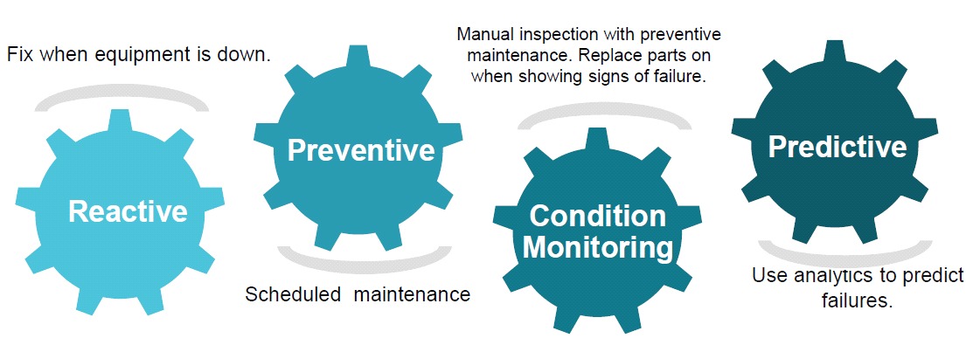

* **About upskill Campus (USC)**

upskill Campus along with The IoT Academy and in association with Uniconverge technologies has facilitated the smooth execution of the complete internship process.

USC is a career development platform that delivers **personalized executive coaching** in a more affordable, scalable and measurable way.

Seeing need of upskilling in self paced manner along-with additional support services e.g. Internship, projects, interaction with Industry experts, Career growth Services

<https://www.upskillcampus.com/>

upSkill Campus aiming to upskill 1 million learners in next 5 year\

* **The IoT Academy**

The IoT academy is EdTech Division of UCT that is running long executive certification programs in collaboration with EICT Academy, IITK, IITR and IITG in multiple domains.

* **Objectives of this Internship program**

The objective for this internship program was to

 ☛ get practical experience of working in the industry.

 ☛ to solve real world problems.

 ☛ to have improved job prospects.

 ☛ to have Improved understanding of our field and its applications.

 ☛ to have Personal growth like better communication and problem solving.

* **Reference**

1. JavatPoint

Website: https://www.javatpoint.com/java-tutorial

2. Oracle Java

Website: https://docs.oracle.com/en/java/

* **Glossary**

|  |  |
| --- | --- |
| Terms | Acronym |
| Console-based expense tracker application | CBETA |
| Application Programming Interface | API |
|  |  |
| Java  Database Connectivity | JDBC |
| User Interface | UI |

* **Problem Statement**

1. Expense Tracking: Provide a platform for users to track and manage their expenses and income.
2. Category Management: Users input commands or options to create, modify, or delete expense categories.
3. Filtering Criteria: Users input criteria such as date range, category, or amount to filter and view specific expenses.
4. User Authentication: Implement a secure login system to ensure authorized access to user accounts.
5. Modification or Deletion Requests: Users input the expense details they want to modify or delete, such as the expense ID or specific attributes.

The problem statement aims to address the challenges faced in expense tracking for the user and provide a user friendly ui so that they can easily use it and track their expenses.

* **Existing and Proposed solution**

1. Text based expense tracker- User can just write down its expenses and kept record for that.
2. Spreadsheet based expense tracker- A much better way of keeping track of expenses than text based.

**Limitations** of existing solutions may include, inputting all the data manually which is a time consuming process, lack of features, lack of security.

**Proposed Solution:**

* Web based expense tracker
* Mobile app expense tracker
* AI based expense tracker

**Value Addition:**

* *Enhanced functionality:* The proposed solution will offer a wide range of operations to perform for the user.
* *Improved user experience:* The system will have an intuitive and user-friendly interface, allowing customers to easily navigate and track their expenses.
* *Robust security measures:* The solution will prioritize data security and implement measures to protect customer information and prevent unauthorized access.
* **Code submission (Github link)**

Github Link :- <https://github.com/himughanakash/UpSkill-Campus>

**Report submission (Github link) :** Copy the link.

* **Proposed Design/ Model**

The proposed design/model of the Console based expense tracker system follows a structured flow from the initial stages to the final outcome.

1. **Requirements Gathering:** The project begins by identifying and understanding the requirements of the system.
2. **System Design:** Based on the gathered requirements, a system design is created. This includes defining the overall architecture, data flow, and user interface design.
3. **Development:** The development phase involves implementing the system design using Java technologies. This includes writing the code, integrating modules and ensuring proper functionality.
4. **Testing and Debugging:** Once the development is complete, the system undergoes thorough testing to identify and fix any type of bugs. Testing involves validating the system's behaviour, functionality, and performance to ensure it meets the specified requirements.
5. **Iterative Improvements:** Based on the testing results and user feedback, iterative improvements are made to enhance the system's usability, efficiency, and reliability.
6. **Documentation**: Throughout the design and development process, documentation is created to record the system's architecture, functionality, and usage instructions. This documentation helps in understanding and maintaining the system in the future.
7. **Deployment and Rollout:** Once the system is thoroughly tested and refined, it is deployed in the production environment.
8. **User Training and Support:** Users are provided with appropriate training to understand and effectively utilize the system. There’s a support team to check the issues and resolving it properly.

**High Level Diagram (if applicable)**

**Figure 1: HIGH LEVEL DIAGRAM OF THE SYSTEM**

* **Low Level Diagram (if applicable)**
* **Interfaces (if applicable)**

Some UI Samples of Console based expense tracker system.

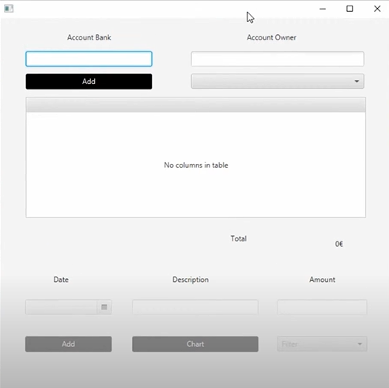

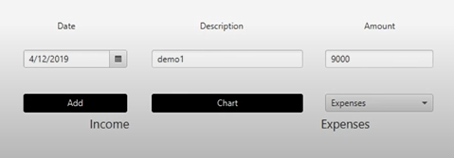

* **Performance Test**

Constraints for Performance for Console based expense tracker system are:

* Memory: Efficient usage of memory resources of computer, data structures.
* Accuracy: Robust data validation, error handling, and comprehensive testing to ensure accurate calculations for the expenses.
* Durability: Handling big data, user input and be not complex.
* Power Consumption: Design for energy efficiency by minimizing resource usage, optimizing code execution, and adopting power-saving techniques.

Importance of Performance Testing:

* Evaluating system performance within identified constraints.
* Assessing response times, throughput, and limitations.
* Identifying bottlenecks and optimizing for improved performance.

**Test Plan/Test Cases :**

1. Test Plan Overview :-

* Objectives and scope of testing defined.
* Key functionalities and modules identified.
* Testing approach, environment, and resources specified.

2. Test Cases :-

* Test case 1: Successfully adding account bank and account owner
* Test case 2: Adding of expensed with description(topic on which money got spended) and date.
* Test case 3: Compilation and proper results for expenses.
* Test case 4: Successfully adding expenses window.

3. Test Procedure:

* Execute test cases following the testing approach.
* Record actual results or issues encountered.
* Document bug reporting and resolution steps.
* Repeat test cycles as needed for comprehensive coverage.

**Performance Outcome:**

* Measure system performance based on predefined metrics.
* Analyze results to identify bottlenecks, limitations, and areas for improvement.
* Evaluate if system meets performance requirements defined in the test plan.

**My learnings**

Working on the Console based expense tracker system project has provided valuable learnings for my career growth:

1. Enhanced technical skills in Java, SQL, and object-oriented programming.
2. Improved project management abilities through requirements gathering and system design.
3. Strengthened problem-solving skills by overcoming implementation challenges.

4. Developed effective collaboration and communication skills within a team.

**Future work scope**

1. Enhanced security features: Enhancing the security so that the expenses are to the user only.
2. Better UI: Working on UI may provide much better user friendly User Experience.
3. Mobile application: A much reliable application for the users on their mobile phone to track their application.

In conclusion, this project has been a valuable learning experience, equipping me with skills for career growth. The Console Based Expense Tracker System is fully ready to meet user’s demand and fulfill their requirements. User can record its any long expense in the application and keep track of that.

[ Thank You ]